* [**How to display a task list on a master calendar**](https://sharepoint.rackspace.com/Learning/Articles/Pages/display-a-task-list-on-a-master-calendar.aspx)

1. From your SharePoint site, open your master Calendar, in this example I will open my “Team Calendar.”

2. At the top of the page click **CALENDAR** to expand the ribbon.

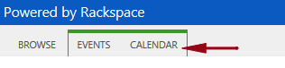

3. In the Manage Views section click **Calendars Overlay**.

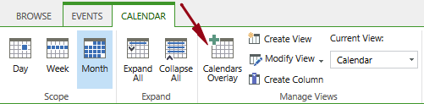

4. On the Calendar Overlay Settings page click **New Calendar**.

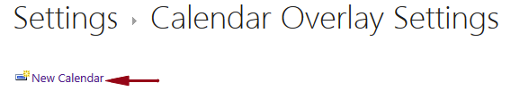

5. In the Name and Type enter the following:

* 1.Calendar Name: **Internal Tasks**
* 2. The type of calendar is: **SharePoint**

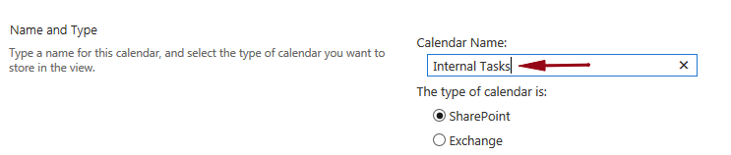

6. In the Calendar Overlay Settings section enter the following information below:

* 3. Description: **Blank**
* 4. Color: **Dark Green, #134029**
* 5. Web URL: (locate the site where your task list resides) click **Resolve**
* 6. List: (select the task list you would like to display) **Team Tasks**
* 7. List View: **Calendar**
* 8. Always show: **unchecked**

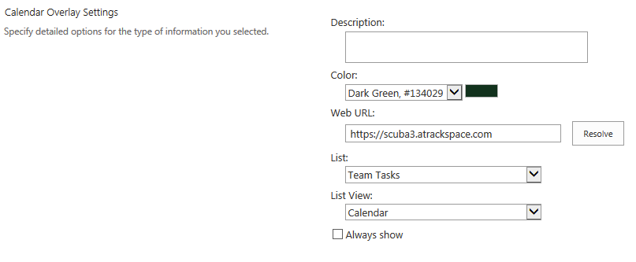

7. Review your settings and click **OK**.  
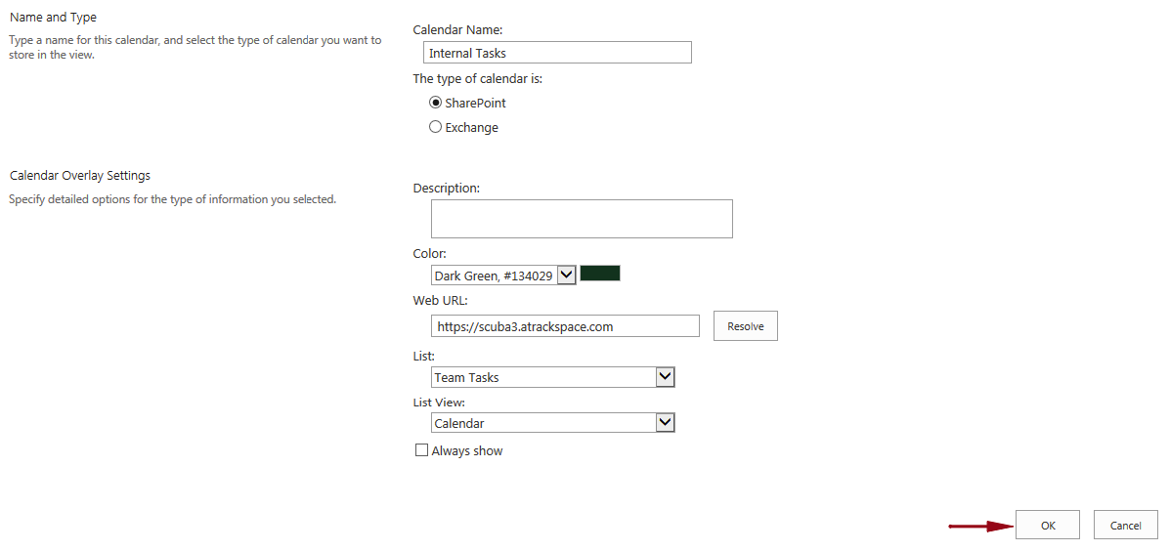  
  
8. Under Additional Calendars you will see your new calendar overlay, which in this example is “**Internal Tasks**.”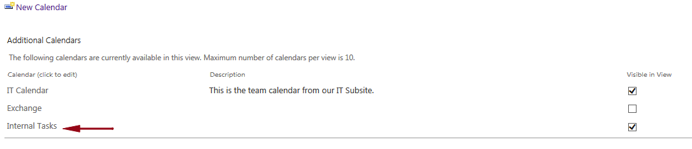

9. Click **OK**.  
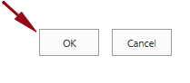

10. You will now see items from your task list, in this example "**Team Tasks**" showing on the master calendar.   
